# MYSQL Comprehensive Assessment

**Topic : Library Management System**

You are going to build a project based on Library Management System. It keeps track of all information about books in the library, their cost, status and total number of books available in the library.

Create a database named library and following TABLES in the database:

1. Branch

2. Employee

3. Books

4. Customer

5. IssueStatus

6. ReturnStatus



Attributes for the tables:

1. Branch

* Branch_no - Set as PRIMARY KEY
* Manager_Id
* Branch_address
* Contact_no

**Input**

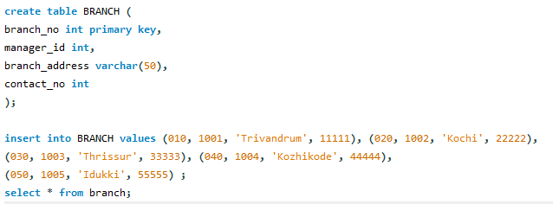

**Output**

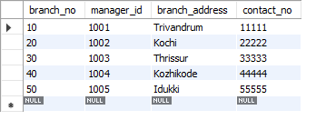

2. Employee

* Emp_Id – Set as PRIMARY KEY
* Emp_name
* Position
* Salary
* Branch_no - Set as FOREIGN KEY and it refer Branch_no in Branch table

**Input**

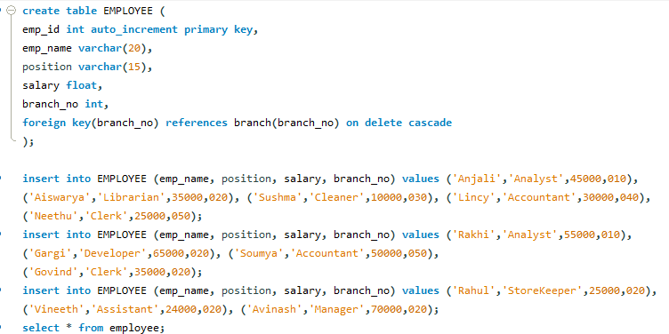

**Output**

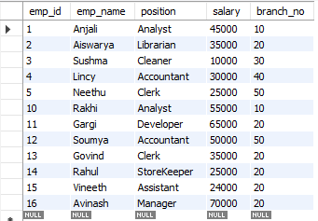

3. Books

* ISBN - Set as PRIMARY KEY
* Book_title
* Category
* Rental_Price
* Status [Give yes if book available and no if book not available]
* Author
* Publisher

**Input**

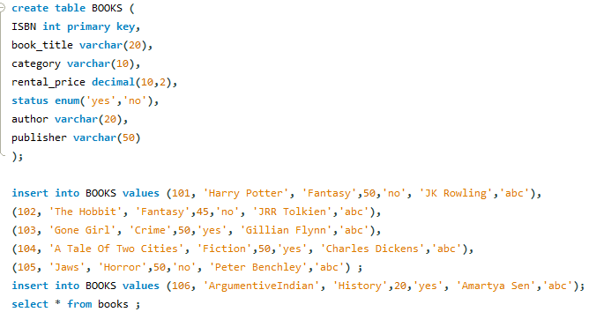

**Output**

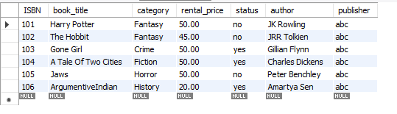

4. Customer

* Customer_Id - Set as PRIMARY KEY
* Customer_name
* Customer_address
* Reg_date

**Input**

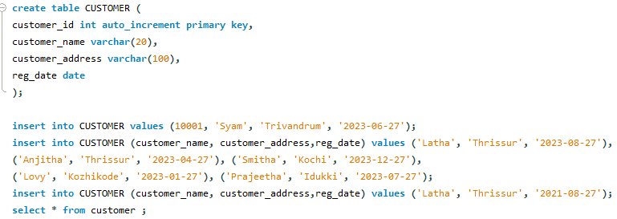

**Output**

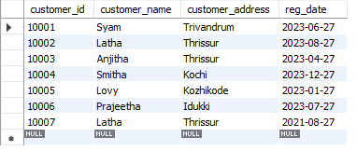

5. IssueStatus

* Issue_Id - Set as PRIMARY KEY
* Issued_cust – Set as FOREIGN KEY and it refer customer_id in CUSTOMER table Issued_book_name
* Issue_date
* Isbn_book – Set as FOREIGN KEY and it should refer isbn in BOOKS table

**Input**

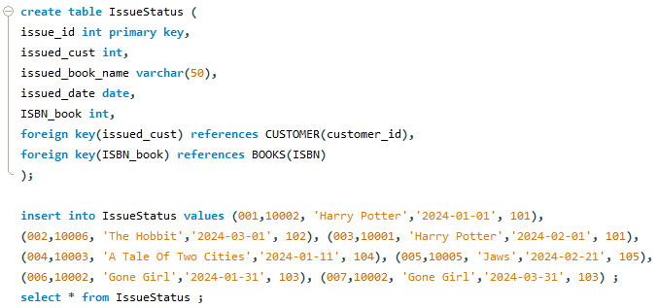

**Output**

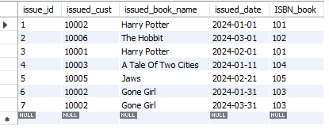

6. ReturnStatus

* Return_Id - Set as PRIMARY KEY
* Return_cust
* Return_book_name
* Return_date
* Isbn_book2 - Set as FOREIGN KEY and it should refer isbn in BOOKS table

**Input**

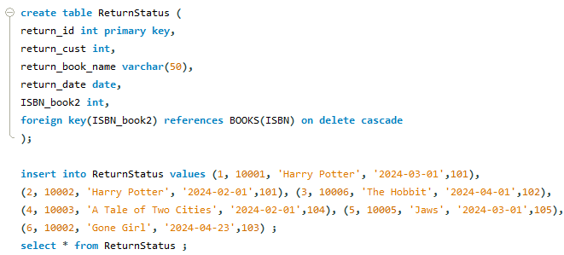

**Output**

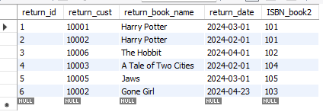

**1. Retrieve the book title, category, and rental price of all available books.**

**Input**



**Output**

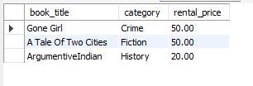

**2. List the employee names and their respective salaries in descending order of salary.**

**Input**



**Output**

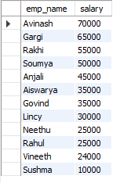

**3. Retrieve the book titles and the corresponding customers who have issued those books.**

**Input**

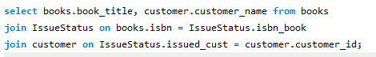

**Output**

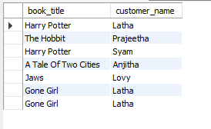

**4. Display the total count of books in each category.**

**Input**



**Output**

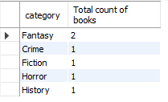

**5. Retrieve the employee names and their positions for the employees whose salaries are above Rs.50,000.**

**Input**



**Output**

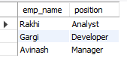

**6. List the customer names who registered before 2022-01-01 and have not issued any books yet.**

**Input**



**Output**



**7. Display the branch numbers and the total count of employees in each branch.**

**Input**



**Output**

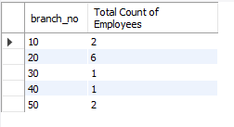

**8. Display the names of customers who have issued books in the month of June 2023.**

**Input**



**Output**

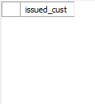

**No customers have issued books in the month of June 2023.**

**9. Retrieve book_title from book table containing history.**

**Input**



**Output**



**10.Retrieve the branch numbers along with the count of employees for branches having more than 5 employees**

**Input**



**Output**



**11. Retrieve the names of employees who manage branches and their respective branch addresses.**

**Input**



**Output**

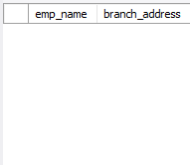

**From the list of employees in the employee table, no one manages the branch.**

**12. Display the names of customers who have issued books with a rental price higher than Rs. 25.**

**Input**

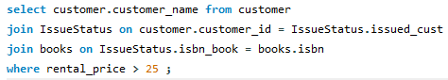

**Output**

